U.N.I.T. Trooper Cosplay from Doctor Who
by Brian Held, Jr.

I've been asked a few times lately about this costume so I wanted to document how I put together my U.N.I.T. Trooper costume for the New Era Doctor Who. This is based off of the appearance of U.N.I.T. in episodes featuring the 9th, 10th, and 11th Doctors as seen here:

Series 1 - Aliens of London / World War Three
Series 2 - The Christmas Invasion
Series 3 - The Sound of Drums / Last of the Time Lords (cameo, UNIT Aircraft)
Series 4 - The Sontaran Stratagem / The Poison Sky, Turn Left (alternate timeline), The Stolen Earth / Journey's End, Planet of the Dead & The End of Time
Series 7 - The Power of Three

*DISCLAIMER* - The materials listed herein are what I chose to represent the costume. This is not meant to be a definitive end all be all representation of what was used in the screen production, I am only going off of my observations of the television show. If you have constructive criticism or additional information to make what I've done here more accurate please e-mail me at byrondelancy@gmail.com.

Each part of the costume will be listed followed by a reference of where is was acquired, a web link if possible, and an average price.

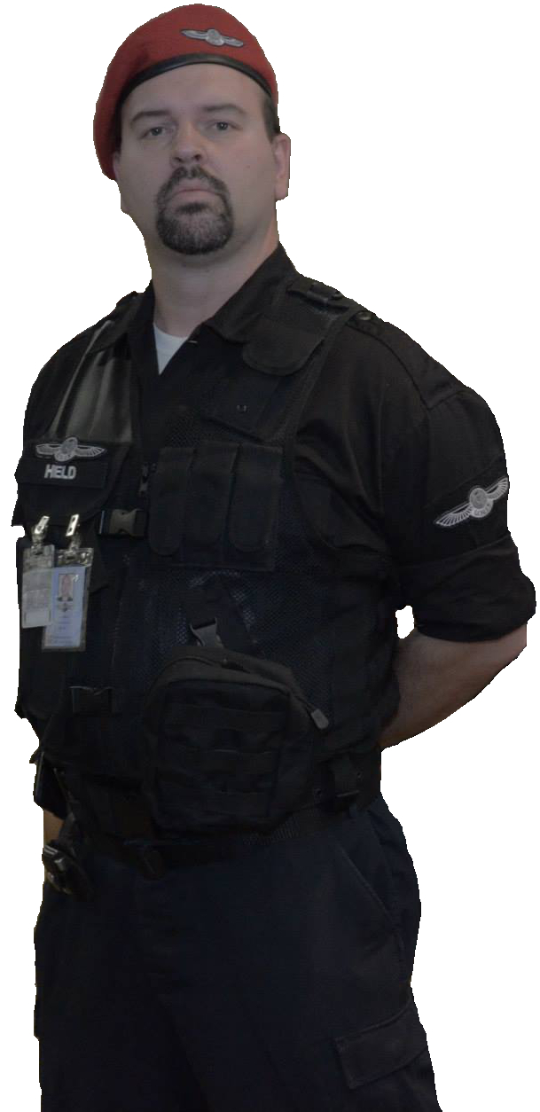

Beret - Purchased from Perret's Army Surplus - Military Berets in Wool http://www.perretsarmysurplus.com/Hats_and_Headwear/GI_Style_Caps_and_Headwear/Military_Berets_in_Wool $12.99

Outer Shirt - Purchased via special order from Perret's Army Surplus - Rothco 6723 Black Long Sleeve Tactical Shirt - https://www.blastlineind.com/ProductDetails.asp?ProductCode=05R6723XS&zmam=38232866&zmas=2&zmac=6&zmap=05R6723XS&gclid=CNvgmbuFpLkCFQto7AodK3MAXw List price $38.48
(This item shows on the Closeout list on Rothco's website. I chose this shirt since it doesn't have the lower pockets that a regular BDU jacket would have making it easier to tuck in.)

Inner shirt - simply a white undershirt

Tactical Vest - Purchased from Perret's Army Surplus - http://www.perretsarmysurplus.com/Cold_and_Outdoor_Clothing/Survival_Gear-Vests/Mach_I_Tactical_Vest-Black $59.99
(I modified the vest to remove the pistol holster from the front and replaced it with a Condor MA21: EMT Pouch in black ~$15.00)

Pants - Purchased from Perret's Army Surplus - ULTRA FORCE™ BLACK POLY/ COTTON TWILL PANTS - http://shop.rothco.com/products/productdetail/part_number=ROT7971/573.0 - $38.49

Belt - Purchased from Perret's Army Surplus - 5.11 1 3/4 TDU Belt - http://www.perretsarmysurplus.com/index.php?main_page=product_info&cPath=335_338&products_id=5189 $14.99

Boots - Purchased from Perret's Army Surplus - HRT Urban 5.11 Tactical Boots -Black - http://www.perretsarmysurplus.com/5.11_Tactical_Store/5.11_Footwear/HRT_Urban_5.11_Tactical_Boots_-Black $149.00

Name tape - Purchased from Perret's Army Surplus - Black Military Name Tapes White Letters Minimum 3 - http://www.perretsarmysurplus.com/Insignia-Flags-License_Plates/GI_Custom_Military_Name_Tapes/Black_Military_Name_Tapes_White_Letters_Minimum_3 $2.75 per

U.N.I.T. Patches - Purchased from patchesnpins.com - http://patchesnpins.com/doctor%20who%20page.htm
1 X Doctor Who new series U.N.I.T. logo beret/cap patch (3"wide) $6.00
3 X Doctor Who new series U.N.I.T. logo patch (4 1/2"wide) $7.00

Velcro tape for patches - Purchased from JoAnn Fabrics - 2" wide by 15" total for 3 4 1/2" patches - I don't recall the per yard price

Total cost -$364.19 (estimate)

U.N.I.T. ID Badge
This is a modified version of the one created by Strollerman (Link below). Feel free to copy and place your information in place of my own. I used a plastic badge from a convention that I had attended in the past to glue this to in order to give it rigidity. I then used the plastic ID badge holder from the same convention badge to wear it.

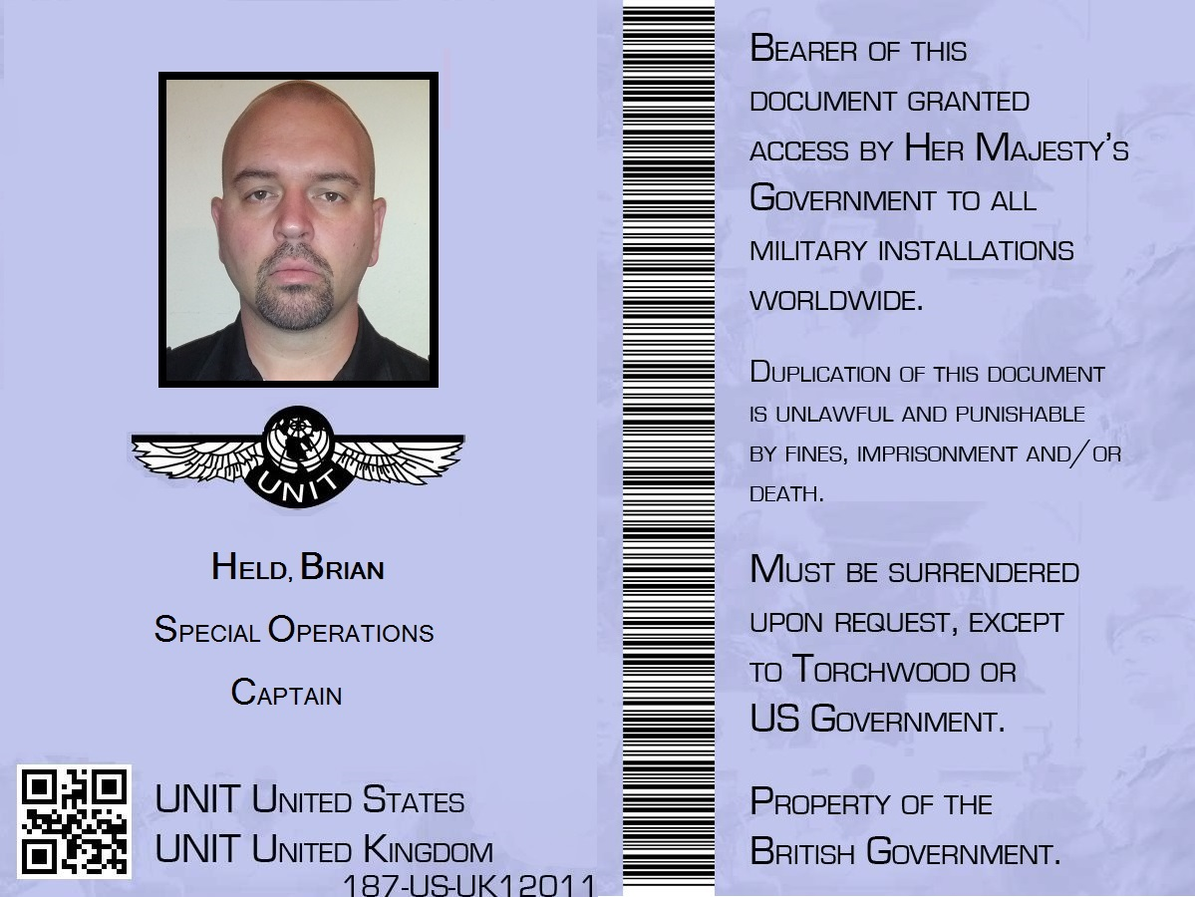

I have not discussed guns for this outfit as I have not purchased the appropriate weaponry for the costume as of yet. I have a Crossman Air Soft pistol that I will occasionally use but it can be a hassle carrying a firearm even if its fake. I'll leave it to your own discretion to research this item. There are many companies out there that produce great looking Air Soft replicas of the weapons carried by the soldiers of U.N.I.T.

Further links of interest:

U.N.I.T. on Wikipedia - http://en.wikipedia.org/wiki/UNIT

Unified Intelligence Taskforce at the Tardis Data Core - http://tardis.wikia.com/wiki/Unified_Intelligence_Taskforce

Strollerman's New Era U.N.I.T. Soldier Breakdown - http://dw-cosplay.livejournal.com/1130336.html

U.N.I.T. Costume from the Doctor Who Experience in Cardiff, Wales http://www.flickr.com/photos/60861613@N00/3469788954/in/set-72157617166343975/
(Notice that there is a jump suit instead of BDUs)

